Dharampeth Education Society’s
R. S. Mundle Dharampeth Arts & Commerce College
North Ambazari Road Nagpur 440010
Ph No.- 0712- 2557612 Fax – 0712-2557612
E-Mail – principalrsmcsn@hotmail.com URL :www.rsmdacc.edu.in

The Principal
______________________
______________________

Subject : Inter-Collegiate Cultural Fest ‘VEDH’ 2019

Dear Madam/Sir,
Warm Greetings and wishes for a Happy New Year
We are glad to inform you that our Annual Culture Fest ’Vedh”, instituted since 2010 as part of the Golden Jubilee Celebration of R.S. Mundle Dharampeth Arts & Commerce College is organized this on 28&29January 2019 wherein the following events will be held. Kindly send entries from your esteemed college..There is no entry fee for ‘Vedh’.
- Debate - (28January 2019, 10 a.m. onwards)
- Group Dance (Folk & Classical) (29January 2019, 11.30 a.m. onwards)
We solicit enthusiastic participation from your college. Please send the entries on or before 24 January 2019.
4. Essay Competition. Please send Essay before 24 January 2019.

Looking forward to your cooperation & patronage.

Thanking you,
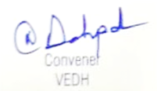

Prof. Ajinkya G. Deshpande Dr. Sandhya Nair
9921624642
For Details Contact:
Prof.MithilaWakhare – 9423155789, Dr.UnnatiDatar - 9423410601
Prof YogeshNikam – 985008792 Prof. SonaliTambuskar – 9423524437,
Prof MurlidharJambulkar- 952760826Prof. SupriyaDani - 8412086641Prof.AbhayDiwe– 7350007428

Group Dance Competition

Dharampeth Education Society’s

NORTH AMBAZARI ROAD, NAGPUR – 440 010, Dial: 0712- 2557612
(Established in 1960)
Accredited Grade “A” by NAAC
URL: www.rsmdacc.edu.in Email :principalrsmcsn@hotmail.com
Dr. Sandhya Nair
Principal

Date: 22/01/2019
NOTICE
It is hereby informed that our college is going to organize Inter Collegiate Group Dance (Folk Dance/ Classical Dance) Competition on 29 January 2019 at 11.30 am. Interested students are required to give your name to Prof. Mithila Wakhare and Prof. Heena Nagbhide on and M.Jambhulakar on before 24 January 2019 and all the students are required to attend the program.
GROUP DANCE: (Folk Dance / Classical Dance)
Inter-Collegiate Folk Dance Competition
- Date of the Event: 29January 2019 Time : 11.30 a.m. onwards
- Last Date of Registration – 24 Jan 2019.
- Venue: R.S Mundle Dharampeth Arts & Commerce College, Nagpur, Old Building, Main Stage
- Number of participants allowed from a college – A group of maximum 10 participants.
- Time Limit- 8Minutes.
- Cash Prizes for the team:-
First Prize : 1500/- Second Prize : 1000/ Third Prize : 750/-
- Rules
- The participants should make the required arrangements for instruments and other accompaniments.
- Participants should bring their CDs/pen drive.
- Participants should be properly dressed.
Contact Person: Prof. Mithila Wakhare-9423155789, Prof. Heena Nagbhide- 9767702657, Prof. M Jambhulkar 9527608265
Report on Intercollegiate Group Dance Competition 2018-19

R. S. Mundle Dharampeth Arts and Commerce College is always striving hard to enhance hidden talent through various activities at its campus With the aim of honouring the dancing skills of students an inter Collegiate Group Dance competition was organised for on 29 January 2019 at 10.00 am. Participants participated either Folk Dance or Classical dance The competition began with great zest and excitement.
The participants, dressed in colourful costumes, set the stage on fire with their enthralling and energetic performance. The competition was a runaway hit. It increased self confidence and self-esteem in the Students.7 teams from 7 different Colleges were participated in the activity.

Name of Event | No of Participants from the college | No of Participants from other college | No of students Participated | No of other colleges | Winner
Group Dance | 10 | 60 | 70 | 7 | 1’st Prize-Hislop college  2’nd Prize- City Premiur College

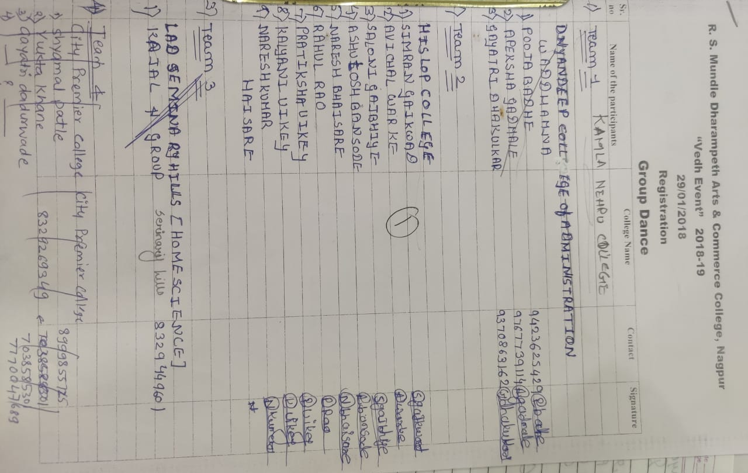

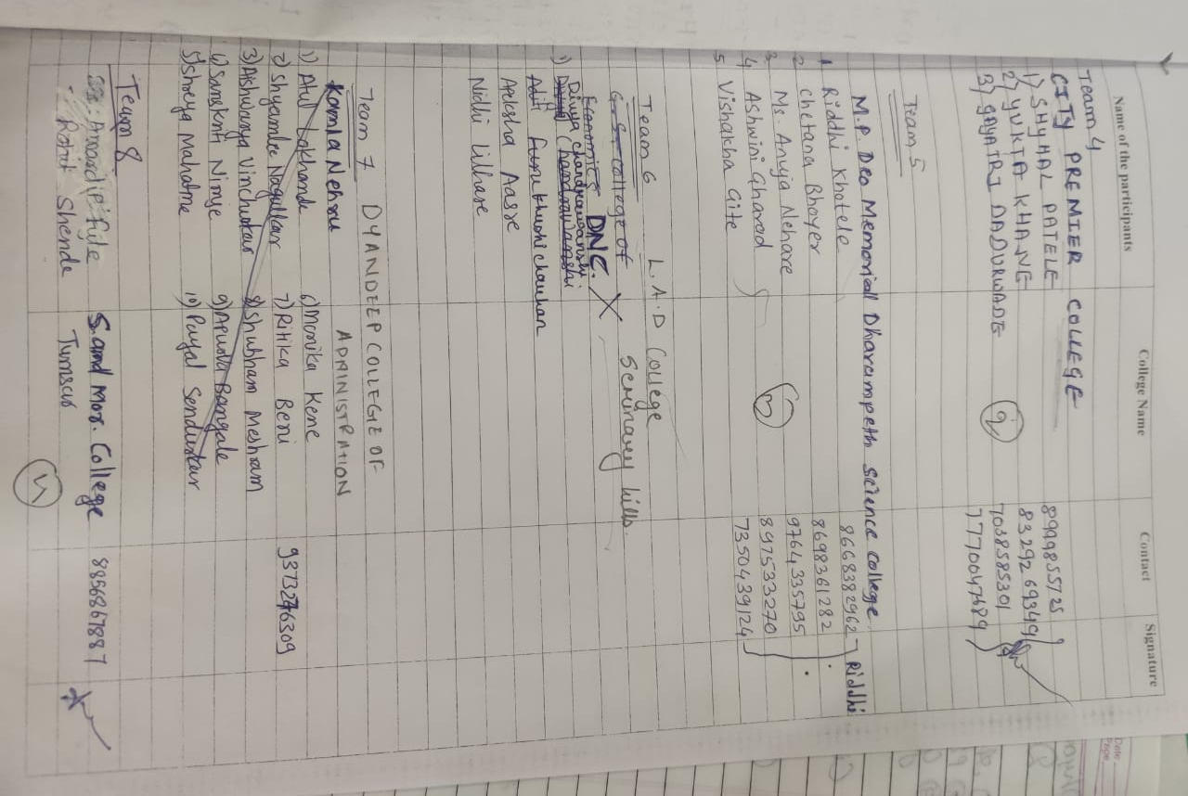

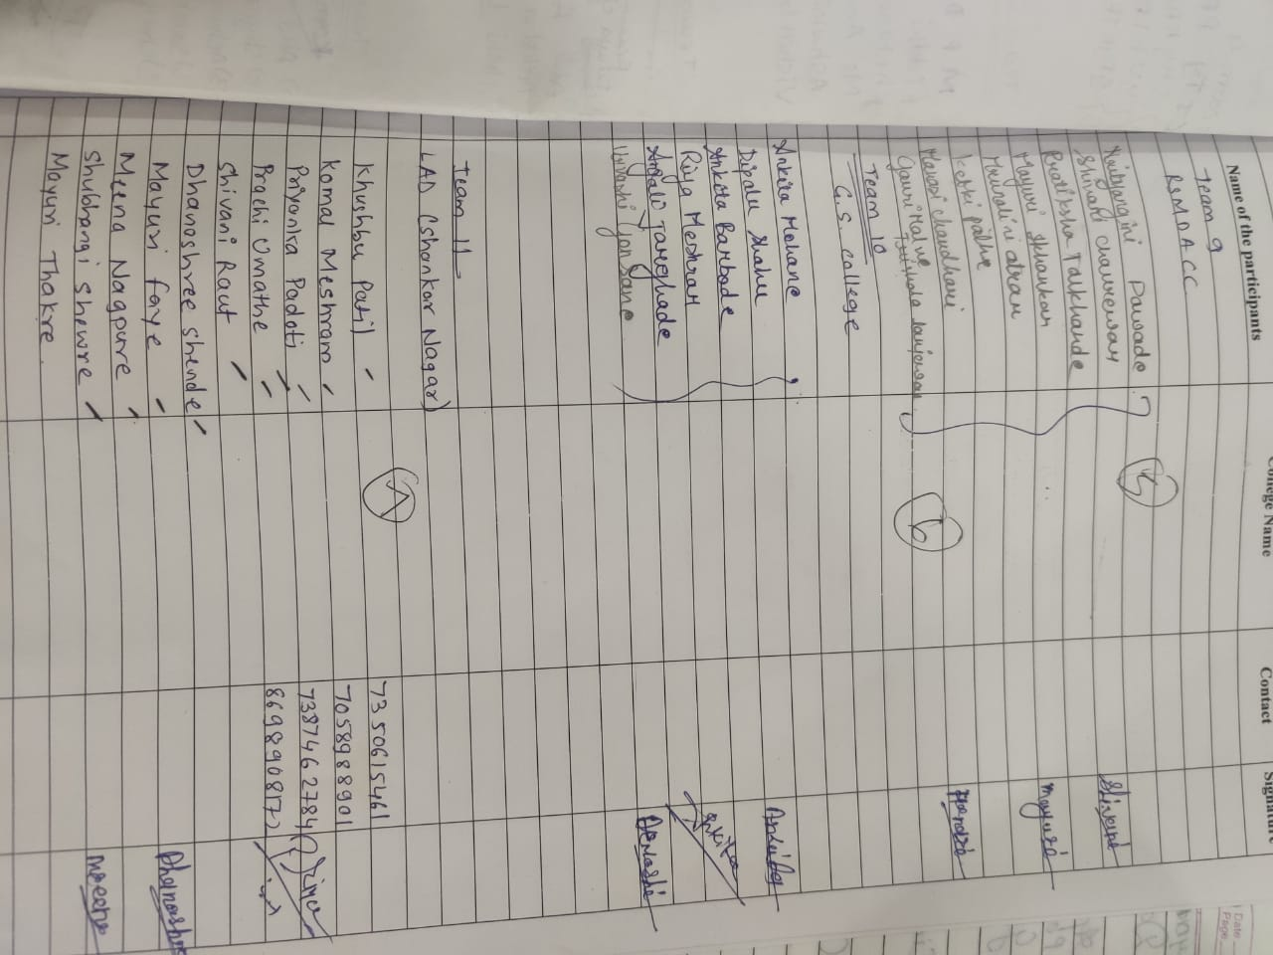

Debate Competition 2018-19

Dharampeth Education Society’s

NORTH AMBAZARI ROAD, NAGPUR – 440 010, Dial: 0712- 2557612
(Established in 1960)
Accredited Grade “A” by NAAC
URL: www.rsmdacc.edu.in Email :principalrsmcsn@hotmail.com
Dr. Sandhya Nair
Principal

Date: 22/01/2019
NOTICE
It is hereby informed that our college is going to organize Inter Collegiate Debate Competition on 28 January 2019 at 10.00 am. Interested students are required to give your name to Dr.Unnati Datar, Prof. Shweta Sharma, Prof. Sharwari Gadge Prof. Zehra Khwaja on and before 24 January 2019 and all the students are required to attend the program.
DEBATE COMPETITION
- Inter-Collegiate Debate Competition
Topic :Should a Minimum Qualification be made Mandatory for a Political Career?
राजकीय कारकिर्दीत किमान शैक्षणिक पात्रता अनिवार्य केली पाहिजे का?
क्या राजनीतिक करियर के लिये न्यूनतम शैक्षणिक योग्यता अनिवार्य होनी चाहिये?
- Date of the Event: 28 January 2019 Time : 10 a.m. onwards
- Last Date of Submission of entry forms : 24 January 2019
- Venue : RSMDACC, Old Building, Raja Harshawardhan Hall, Room no 107,
- Time Limit – 5 minutes
- Number of participants allowed from a college – 02 (one participant with speak for the motion and the other will speak against the motion.)
- Marks would be allotted on clarity of concept, countering of views, felicity of communication and confidence.
- Team Cash Prizes : Rs.500/-
- Individual Cash Prize:First Prize: 300/- Second Prize: 200/
- Note :Participants can speak in Hindi, English or Marathi.
- Contact Persons- Dr.UnnatiDatar- 9423410601, Prof. Shweta Sharma 9371147493, Prof. Sharwari Gadge-9860191316 Prof. ZehraKhwaja 8412996340

Report on Intercollegiate Debate Competition 2018-19
R.S. Mundle Dharampeth Arts & Commerce College conducted a Intercollegiate Debate competition on “Should a Minimum Qualification be made Mandatory for a Political Career? / राजकीय कारकिर्दीत किमान शैक्षणिक पात्रता अनिवार्य केली पाहिजे का ?/क्या राजनीतिक करियर के लिये न्यूनतम शैक्षणिक योग्यता अनिवार्य होनी चाहिये?” 28 January 2019 at 10.00 am. Total 20 students participated in the activity. (2 participants in each team.)
The aim of organizing debate competition was to hone the public speaking skills of the students and teach them to be articulate while expressing their thoughts and opinions. The session was the kaleidoscope of opinions, thoughts and perspective that enhanced the knowledge and understanding about the Education and its importance in Political career, its advantages & Disadvantages.

To begin with, each participant spoke their mind on the rationale for, Education, soul of every field. Unsurprisingly, this led to a wide spectrum of contrasting views – from being heralded as an inevitable future. Points presented were accepted by the spectators with cheers and claps. Some of the points even made us think about the facts. There was so much talent in the room.
Arguments were made and roved. The competition was so interesting with the exchange of student’s perspective by equally stating the merits and demerits Qualification be made Mandatory for a Political Career.

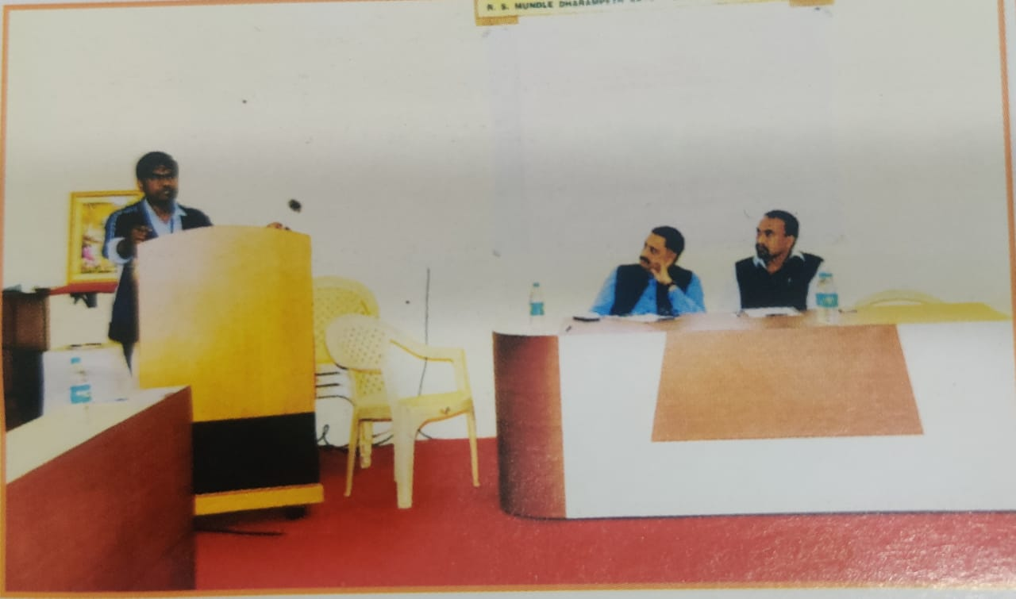

Name of Event | No of Participants from the college | No of Participants from other college | Total No of students participated | No of other colleges | Winner
Debate | 2 | 10 | 20 | 5 | 1’st Prize-  Rupali Chavan,Vaishali Chavan  (Prerna College)  2’nd Prize –  Vishakha Ganorkar ,Kirandip Sandhuk( LAD Collgeg)

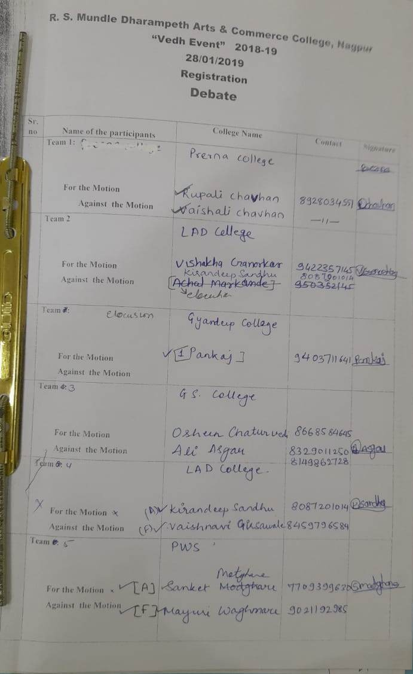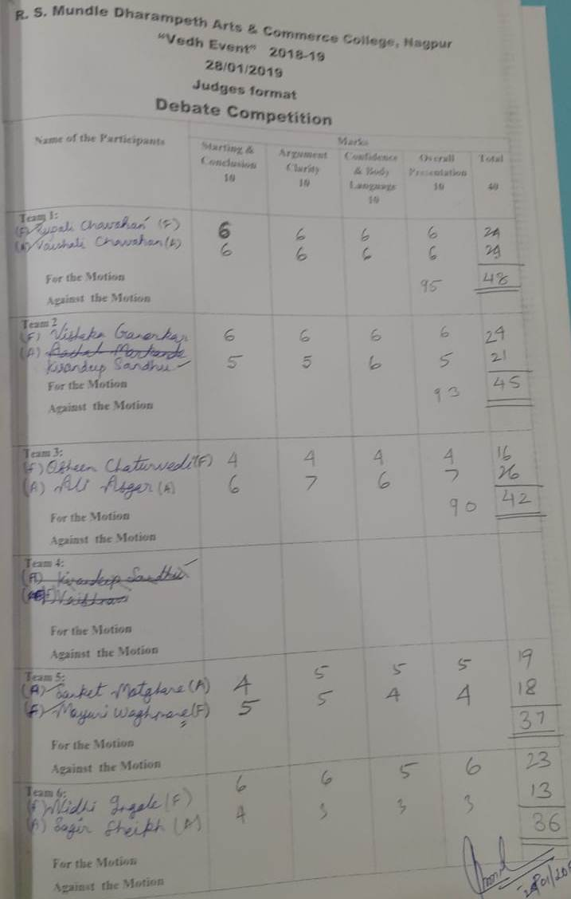

Intercollegiate ESSAY
Competition 2018-19

Dharampeth Education Society’s

NORTH AMBAZARI ROAD, NAGPUR – 440 010, Dial: 0712- 2557612
(Established in 1960)
Accredited Grade “A” by NAAC
URL: www.rsmdacc.edu.in Email :principalrsmcsn@hotmail.com

Date: 22/01/2019
NOTICE
It is hereby informed that our college is going to organize Inter Collegiate Essay Competition. Interested students are required to submit your Essay to Prof..Darshan Labhe,Prof. Sonali Tambuskar and Prof. Supriya Dani on and before 24 January 2019 and all the students are required to attend the program.

ESSAY COMPETITION
Inter – Collegiate Essay Competition
- Topic: ‘Women Empowerment through Sports- Opportunities and Challenges in India.
‘खेळांद्वारे महिलांचे सक्षमीकरण – संधी आणि आव्हाने’
‘खेलो के माध्यम से महिला सशक्तीकरण – अवसर व चुनौतिया’
- Word Limit: Up to 1500 words.
- Last Date of Submission of Essays: 24 January 2019
- Individual Cash Prizes :
First Prize: 500/- Second Prize : 300/ Third Prize : 200/-
- Note :
- Participants can write in their own handwriting in Hindi, English or Marathi.
- The participants should write on ruled paper.
- Marks would be allotted on language, presentation style, logical linking of paragraphs, comprehensiveness and novelty.
Contact Persons: Prof. Supriya Dani- 8412086641, Prof. Sonali Tambuskar-9423524437, Dr.Darshan Labhe 9763188274

Report on Intercollegiate Essay Competition 2018-19

R.S.Mundle Dharampeth Arts & Commerce College organised Intercollegiate Eaasy writing competition. The theme of the Eaasy writing competition was –‘Women Empowerment through Sports- Opportunities and Challenges in India/‘खेळांद्वारे महिलांचे सक्षमीकरण – संधी आणि आव्हाने/‘खेलो के माध्यम से महिला सशक्तीकरण – अवसर व चुनौतिया’ (Word limit was 1500 words) Deadline to submit the essay was 24 January 2018. All the Participants were awarded by Participation certificates and merit Certificates for best three entries. The students from various colleges had participated in the event and helped to make it a great success. There were total 47 entries from 11 Institutes and each essay was so thoughtful and informative. Prof. Sonali Tambuskar, Prof. Darshan Labhe and Prof. Supriya Dani worked hard for the event.
Name of Event | No of Participants from the college | No of Participants from other college | No of students participated | No of other colleges | Winner
Essay Competition | 21 | 26 | 47 | 11 | 1’st Prize-Achal Lande (shriniketan College)  2’nd Prize- PiyushaTelang (G.S.College)
