Report on Students’ English Literary Association
Organised by the Department of English
2019-2020

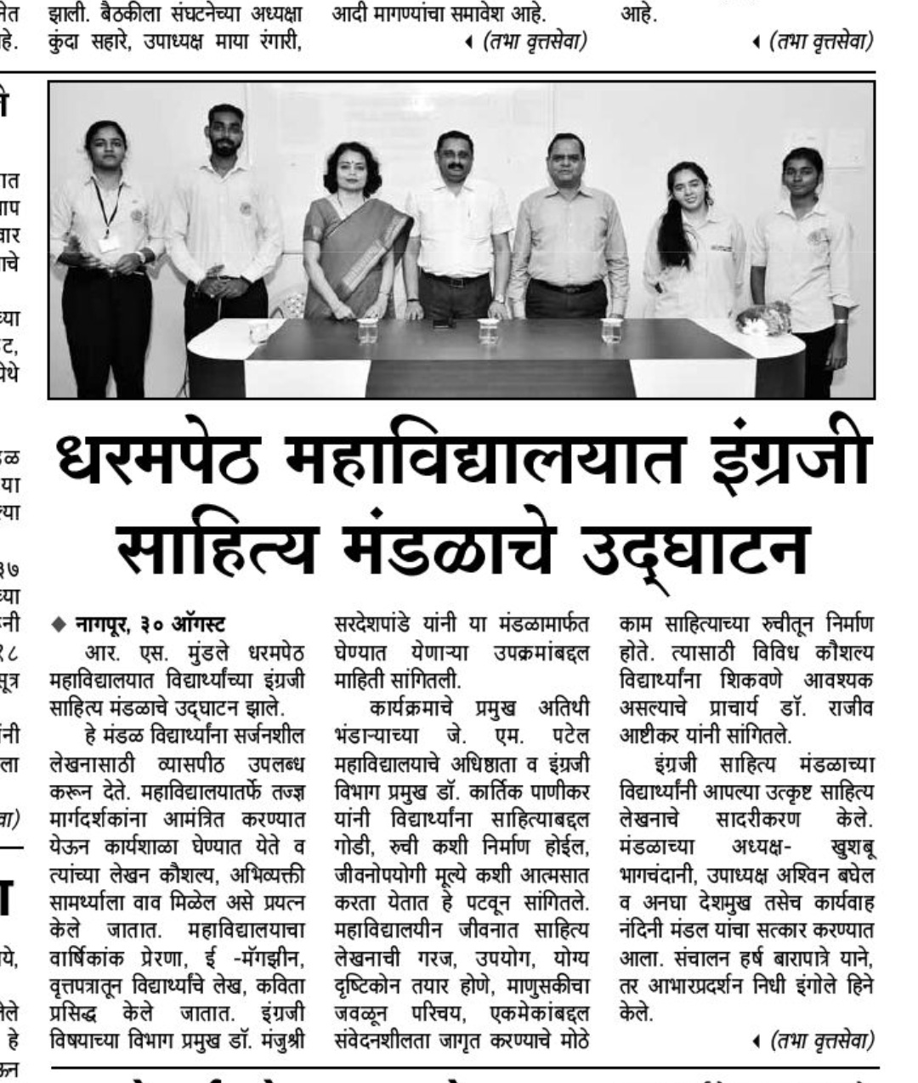
Students’ English Literary Association (SELA) was inaugurated on 27 August 2019 at the hands of Dr. Kartik Panicker, Head of the Department (English) and Dean(administration), J.M. Patel College, Bhandara. Dr. Manjushree Sardeshpande in her introductory remarks informed about the activities conducted by SELA. Student members from all the streams arts, commerce, BBA, BCCA were taught creative writing. SELA provides a platform to the students to hone their literary skills. The creative writings of students is published in the e-magazine Abhivyakti of the college, college magazine Prerna, and also in the youth zone of the Hitavada. The members of SELA who presented their writings were Ms. Nidhi Ingole, Ms. Summaiya Sheikh, Srushti Bhajipale, Gaurav Kolhe, Khushboo Bhagchandani, Kalyani Gadre, Isha Bodele and Mr. Abhishek. The writings of Anuj Warsekar, Aparna Jangati, Aditi Chaudhari, Nandini Mandal, Mohini Tiwari, were published in the college magazine Prerna. The Chief Guest appreciated the creative talent of the budding writers and spoke at length about how literature moulded the views, opinions, perceptions of an individual. Principal Dr. Rajiv Ashtikar explained how the power of expression can enhance one’s career. He also elaborated about the various platforms available to the students in the college. The office bearers of SELA were, Ms. Khushboo Bhagchandani as President, Mr. Ashwin Baghel as Vice-President, Ms. Nandini Mandal as Secretary were felicitated on the occasion. Mr. Harsh Barapatre of B.A. conducted the proceedings and Ms. Nidhi Ingole of B. Com proposed the vote of thanks. The faculty members of the English department and all the members of SELA graced the occasion.

Dr. Rajiv Ashtikar Dr. Manjushree Sardeshpande
Principal Convener

