Intercollegiate Rangoli Competition 2018-19

Dharampeth Education Society’s

NORTH AMBAZARI ROAD, NAGPUR – 440 010, Dial: 0712- 2557612
(Established in 1960)
Accredited Grade “A” by NAAC
URL: www.rsmdacc.edu.in Email :principalrsmcsn@hotmail.com
Dr. Sandhya Nair
Principal

Date: 22/01/2018
NOTICE
It is hereby informed that our college is going to organize Inter Collegiate Rangoli Competition on 28 January 2019 at 09.00 am. Interested students are required to give your name to Prof.Khushbu Vyas,prof. Sheetal Bhonde and Dr. Bhavana Deshmukh on and before 25 January 2018 and all the students are required to attend the program.
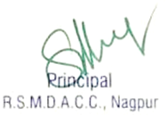
RANGOLI
Inter – Collegiate RangoliCompetition (Free Hand and Geometric)
- Date of the Event: 28January 2019 Time : 9 a.m. to 10 a.m.
- Venue of Event & Registration : RSMDACC, New building – Ground floor corridor and Old building,-First floor-corridor
- Max number of participants – 02 from each college.
- Cash Prizes :
First Prize : 500/- Second Prize : 300/ Third Prize : 200/-
- Rules :
- The participants should bring the required material.
- The participants have to get themselvesregistered at the registration counter and draw the Rangoli on her or his allotted registration number.
- Contact Persons 1) Dr.Bhavana Deshmukh- 7776062200 2) Prof. KhushbuVyas 9923586850
3) Prof. Sheetal Bhonde- 7517042533

REPORT ON INTERCOLLEGIATE RANGOLI COMPETITION 2018-19

R. S. Mundle Dharampeth Arts and Commerce College is always striving hard to enhance hidden talent through various activities at its campus. As one more step, college had organized Intercollegiate Rangoli Competition on 30 January 2018 at New building – Ground floor corridor and Old building,-First floor-corridor R. S. Mundle Dharampeth Arts and Commerce College. The theme was “Festive”, and brought out the fervour of the students.
Total 17 participants painstakingly worked on their rangoli patterns and colors to bring out their talent. Prof.Khushbu Vyas,prof. Sheetal Bhonde and Dr. Bhavana Deshmukh also drew a rangoli to boost the enthusiasm of the students.
They were the teachers in charge for this activity.

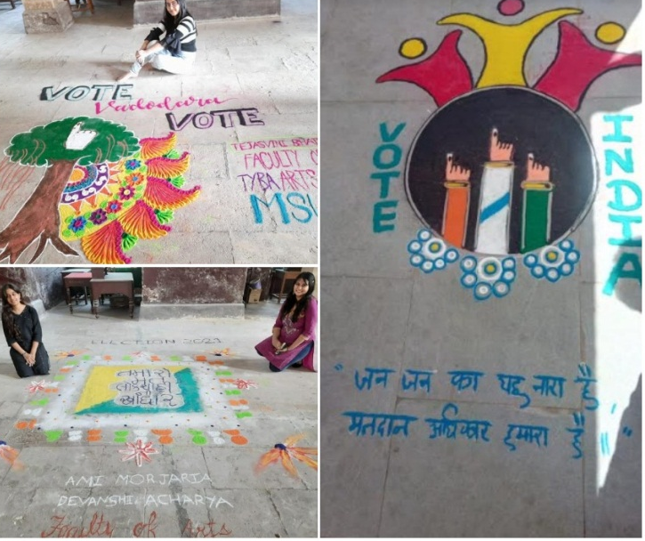
Results for the events are

Name of Event | No of Participants from the college | No of Participants from other college | No of students attended | No of other colleges | Winner
Rangoli | 4 | 13 | 17 | 7 | 1’st Prize-  Arpita Joshi  ( Dharampeth Science College)  2’nd Prize - SnehaTagde ( LAD College)

