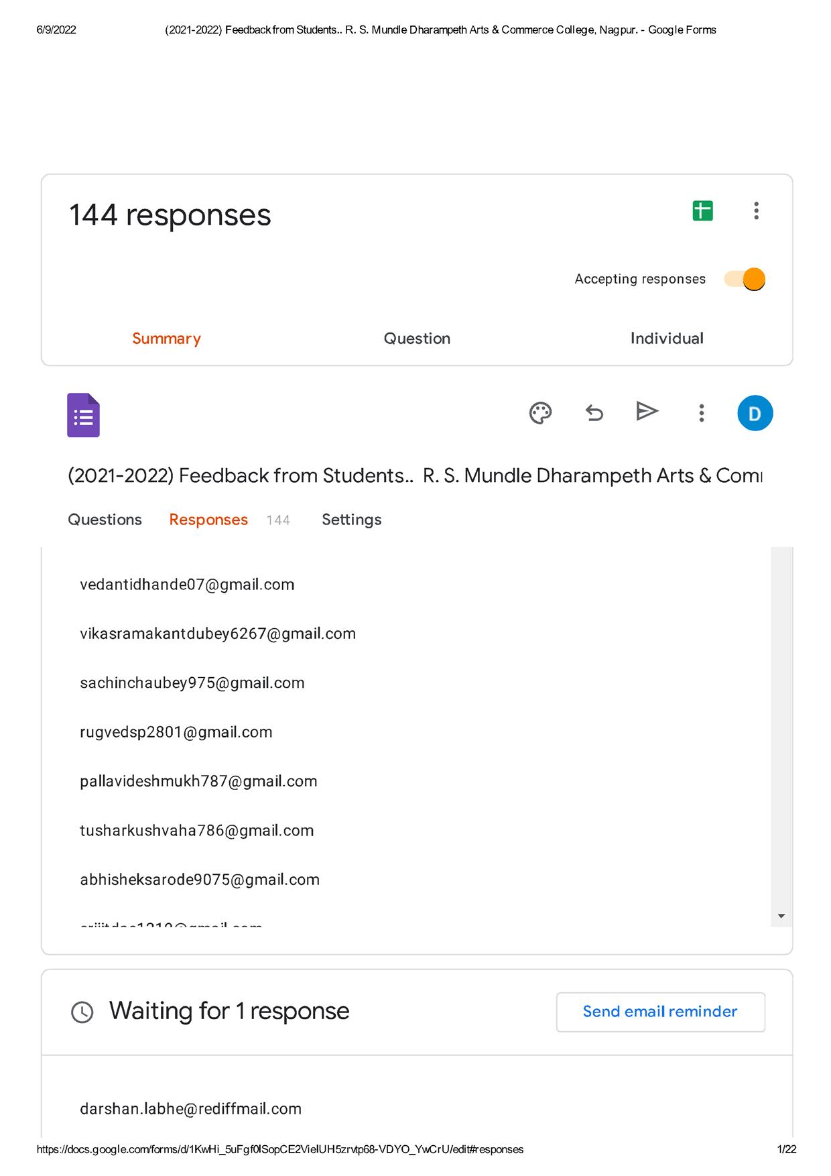

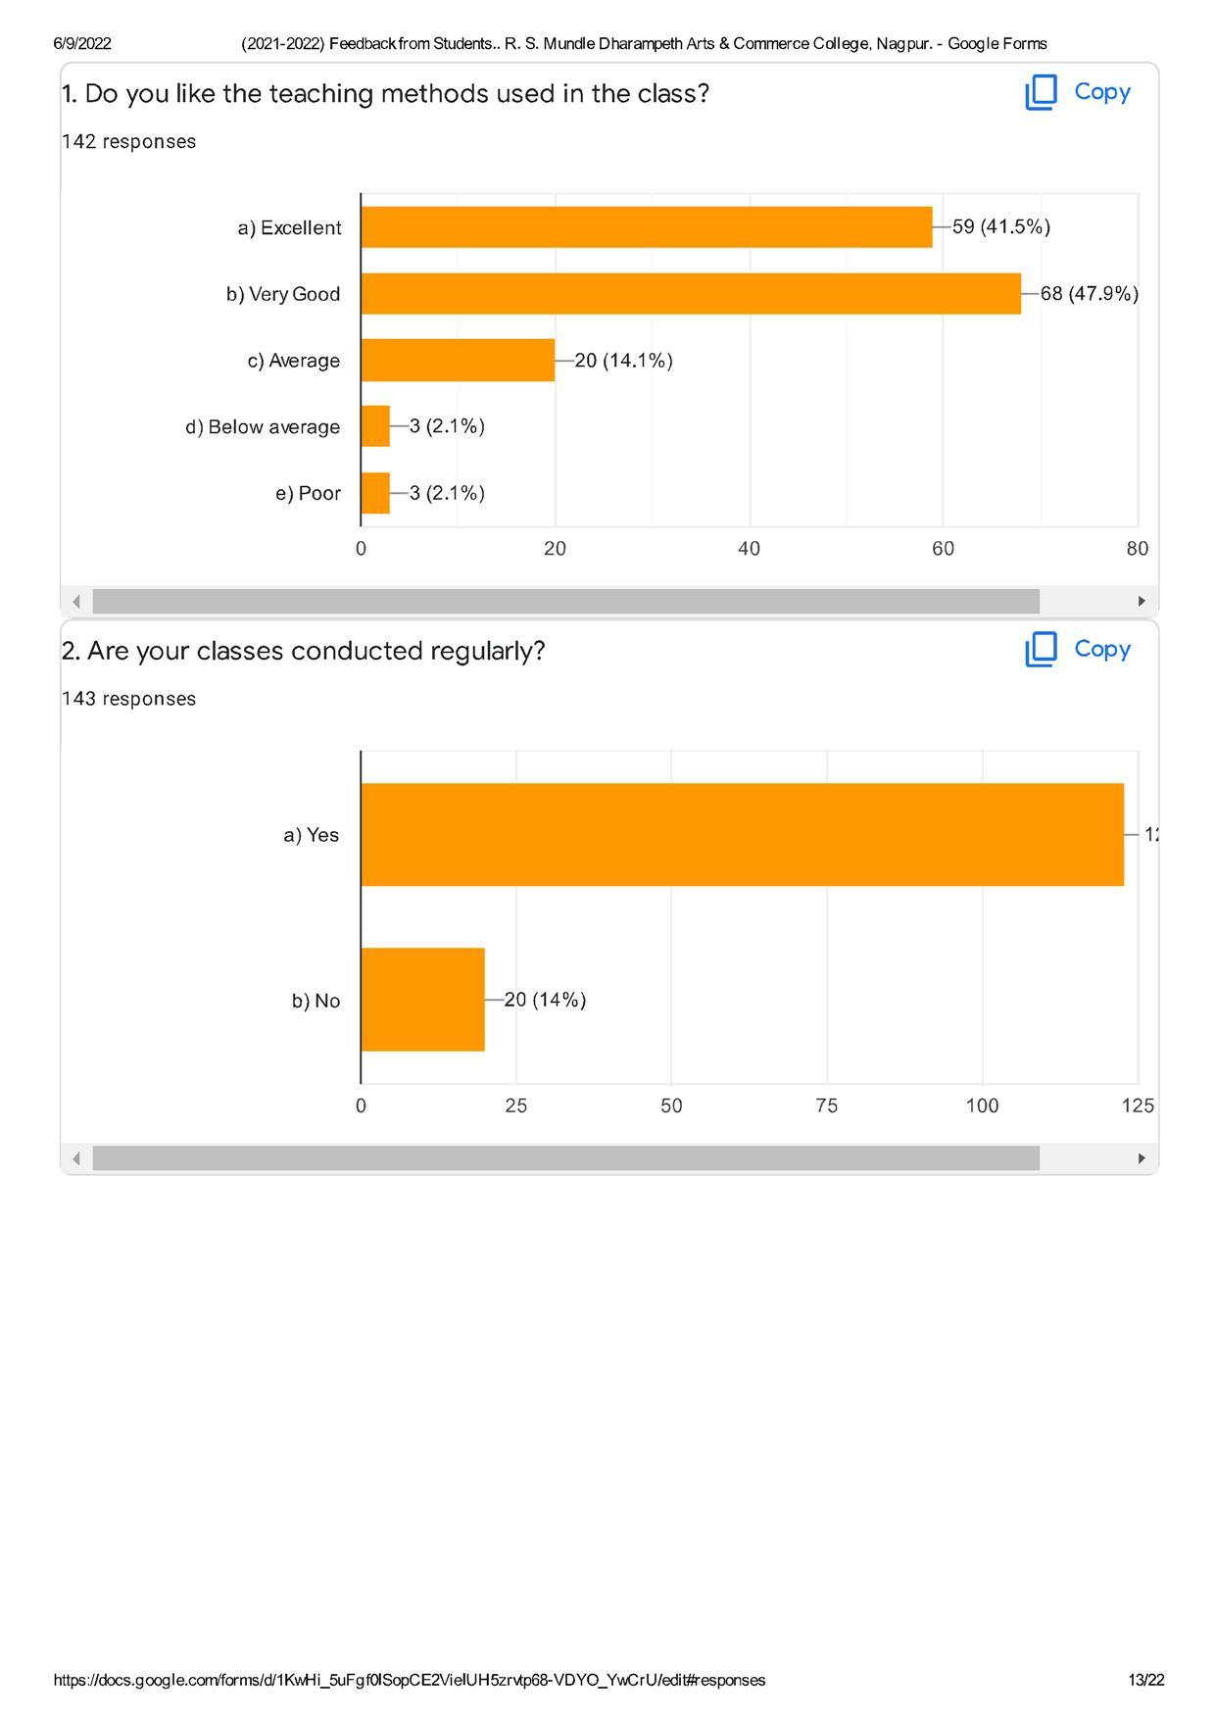

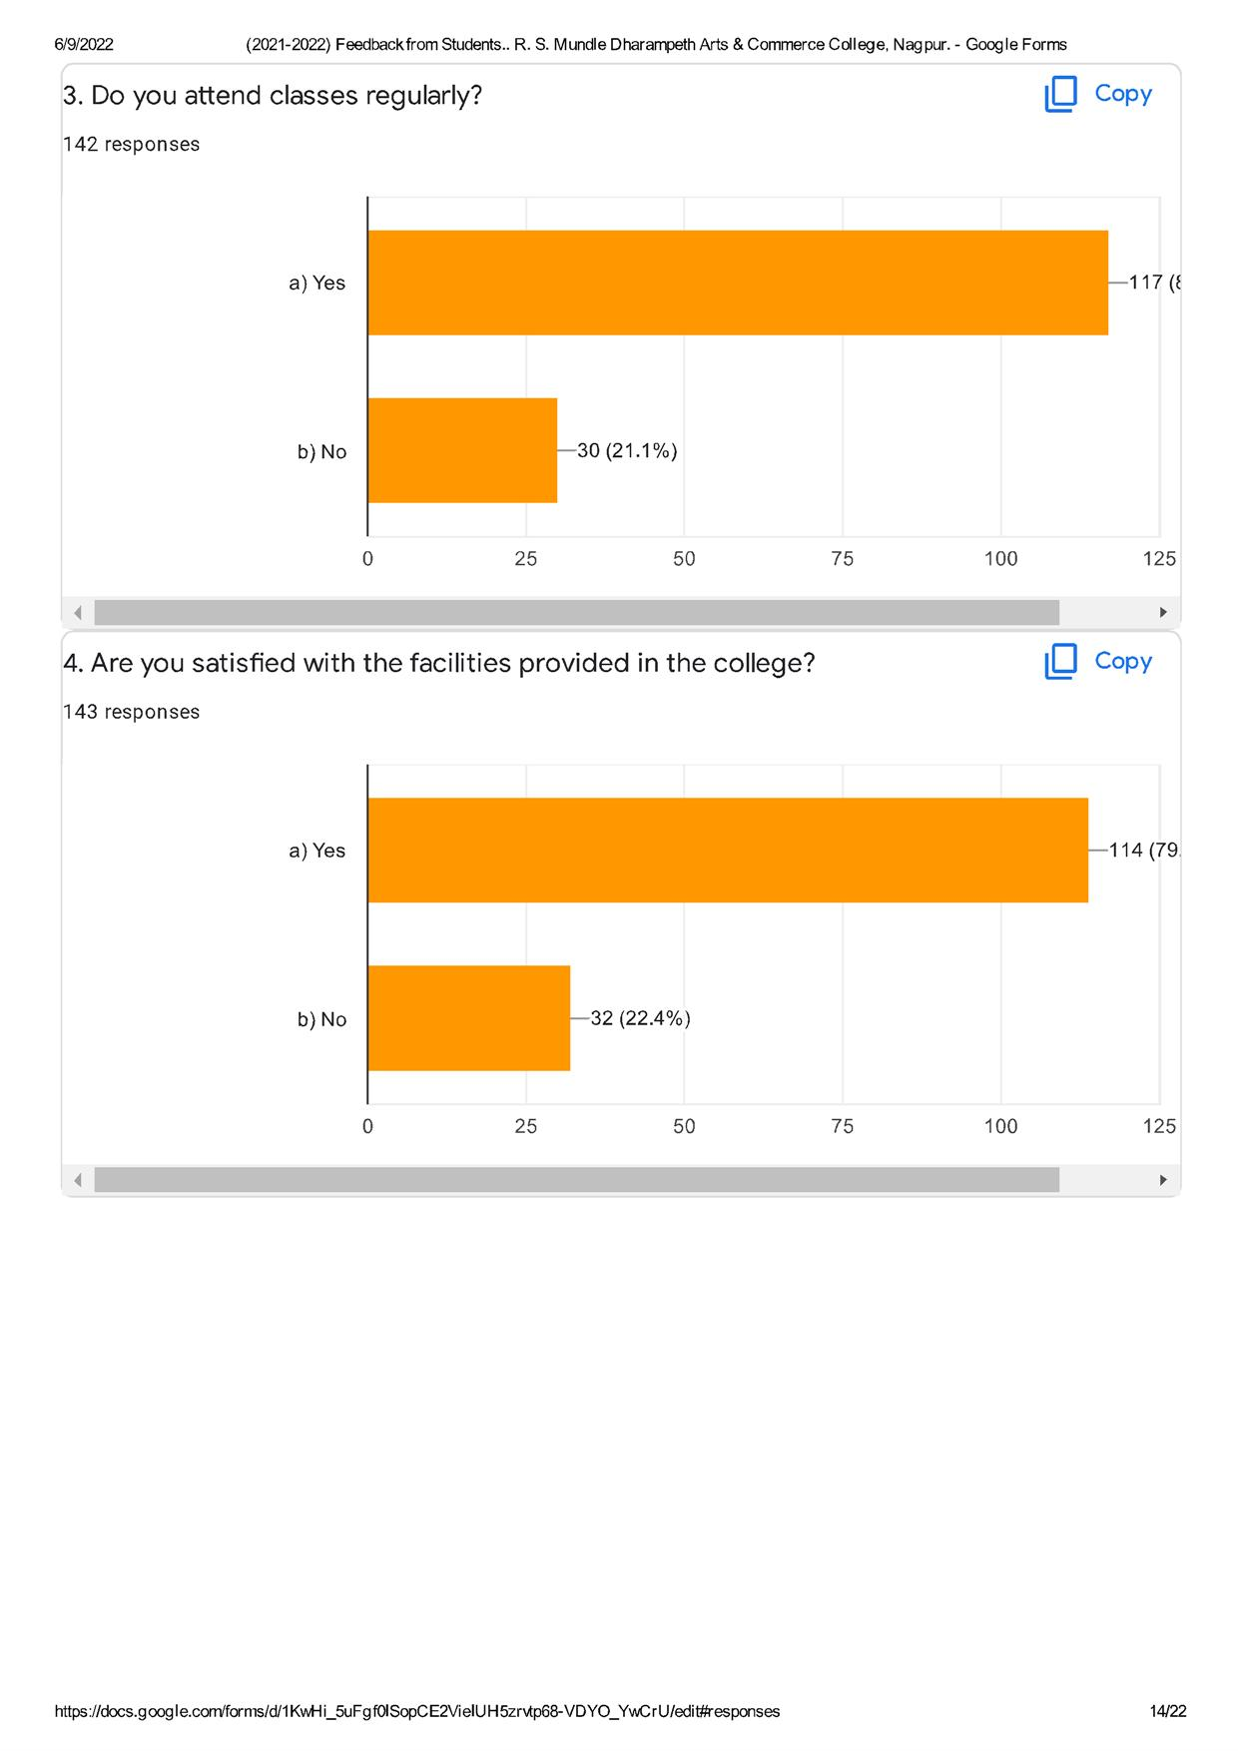

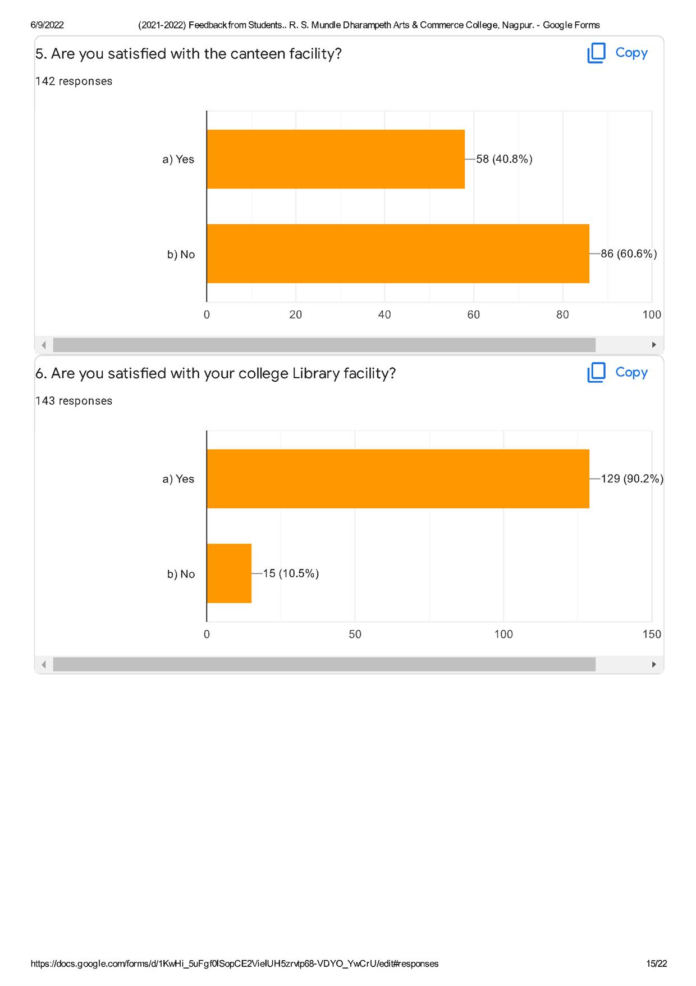

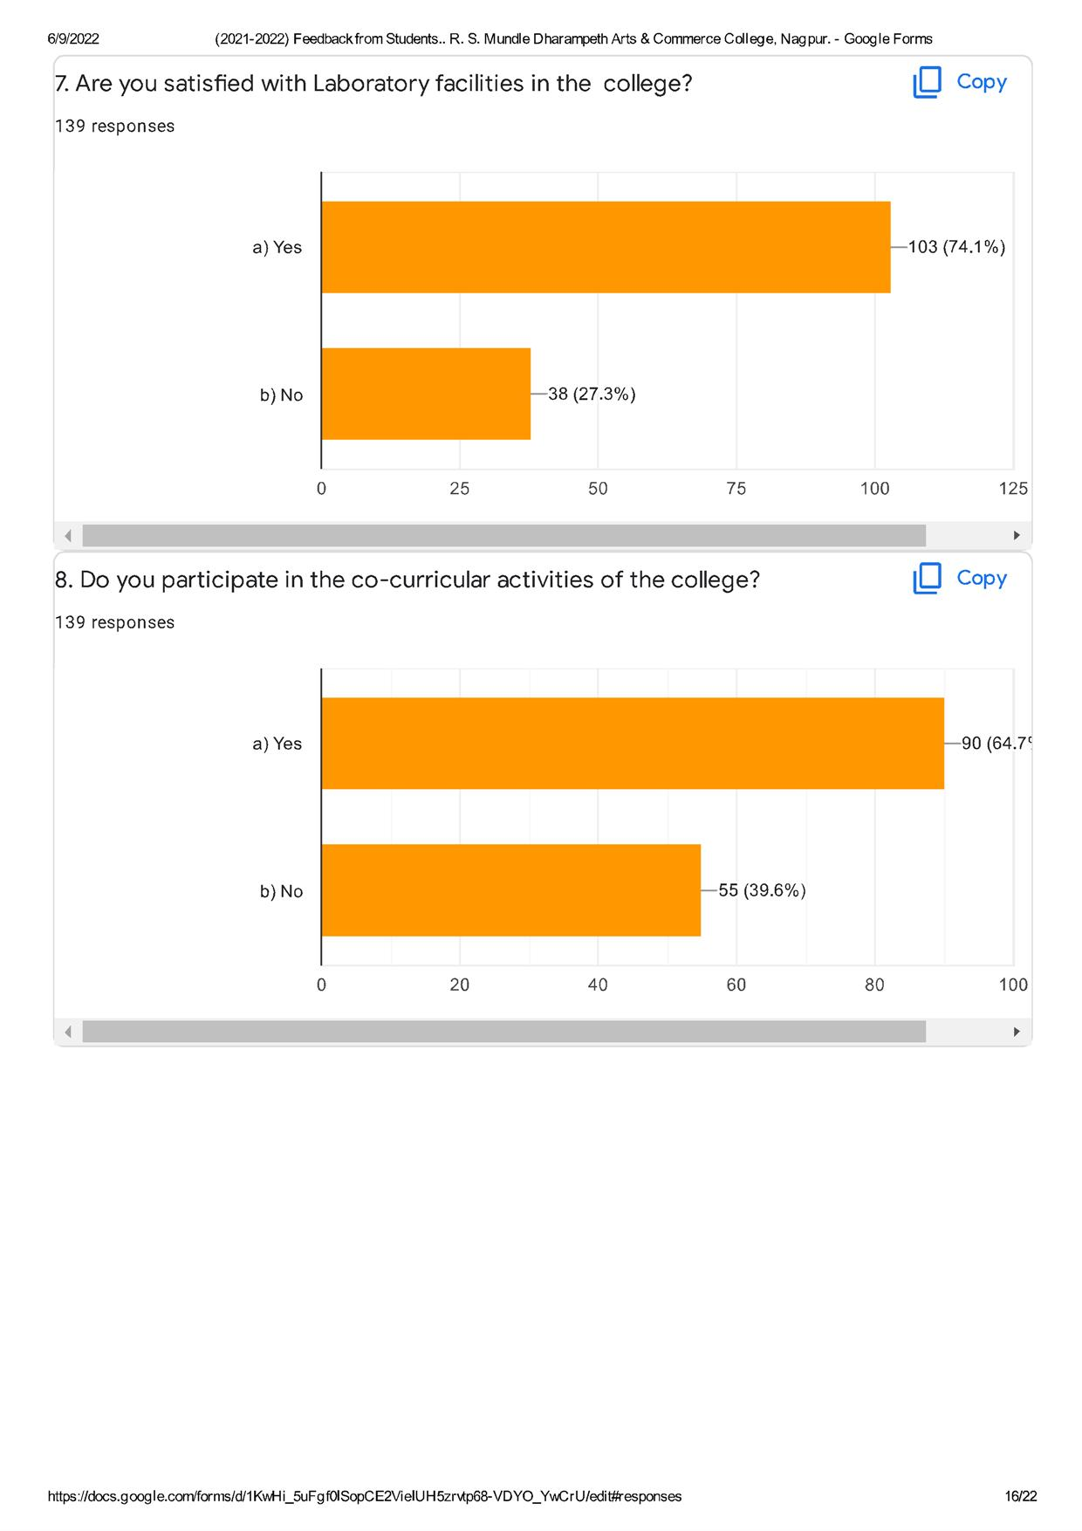

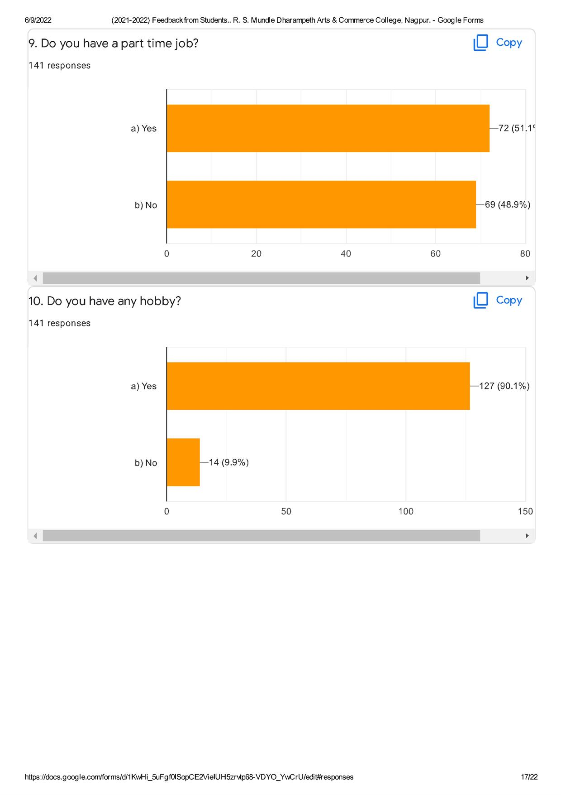

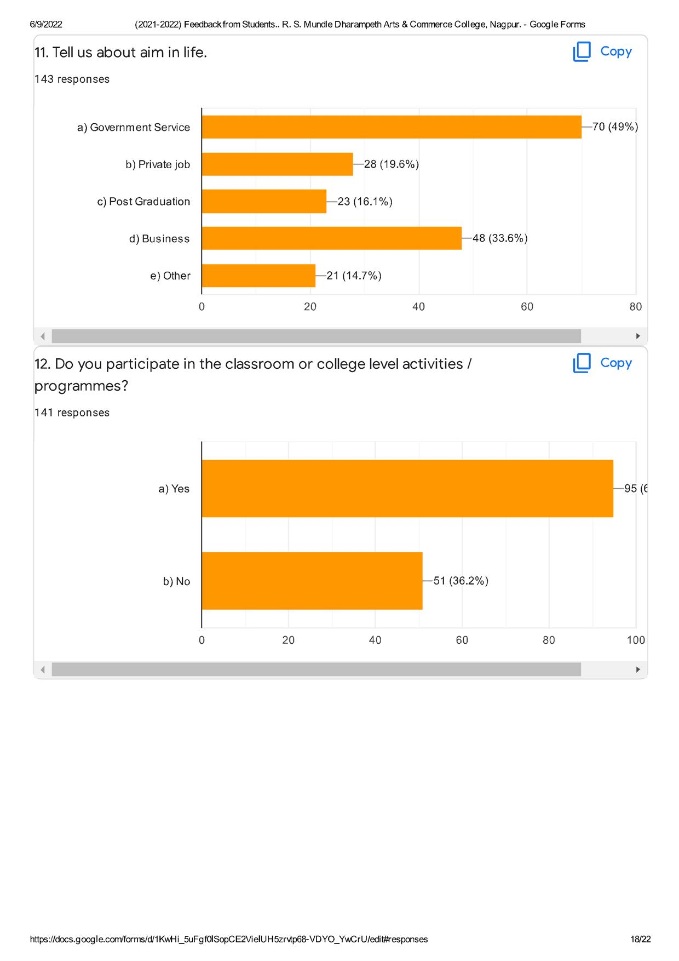

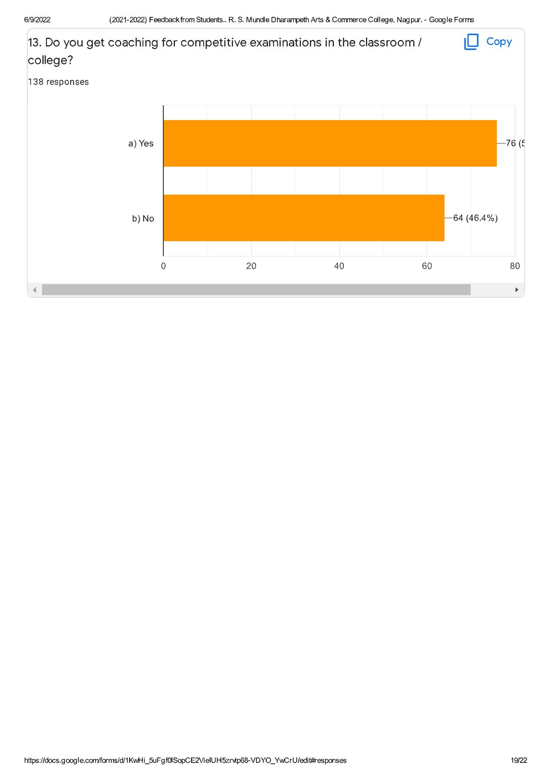

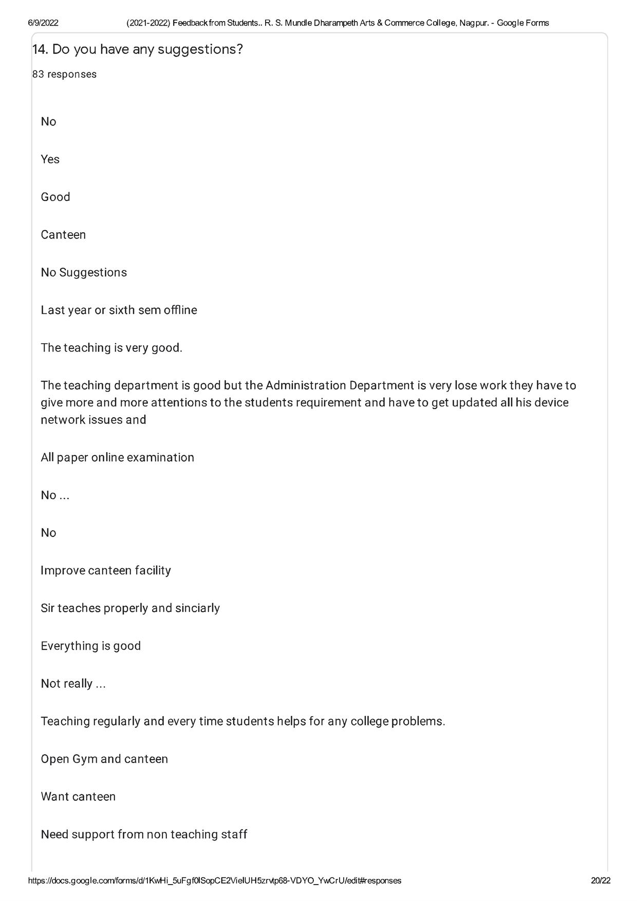

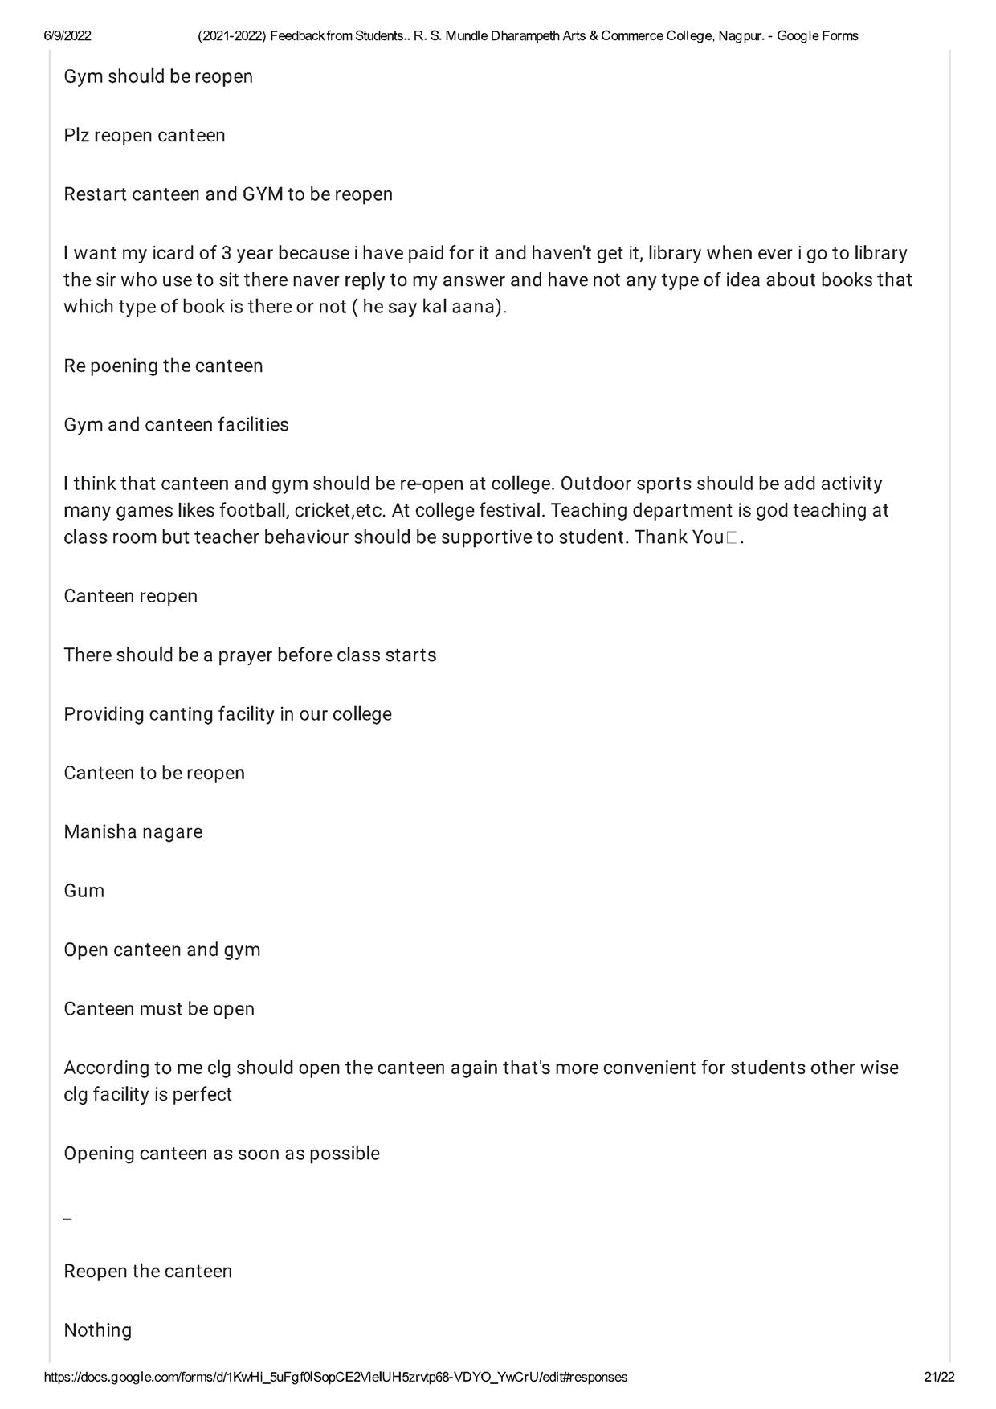

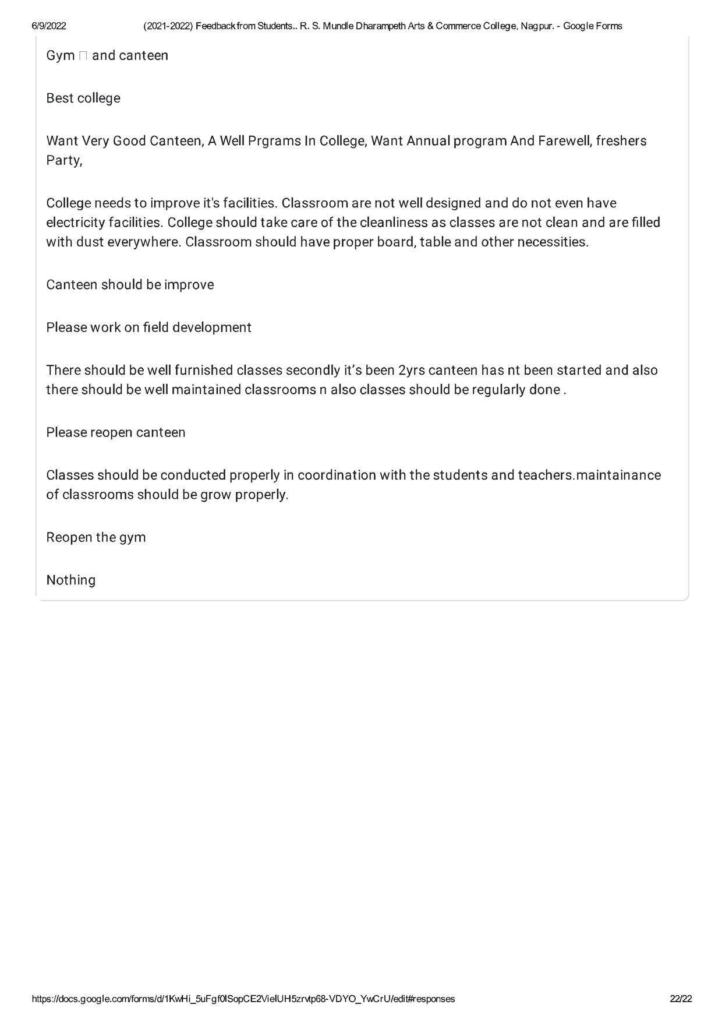

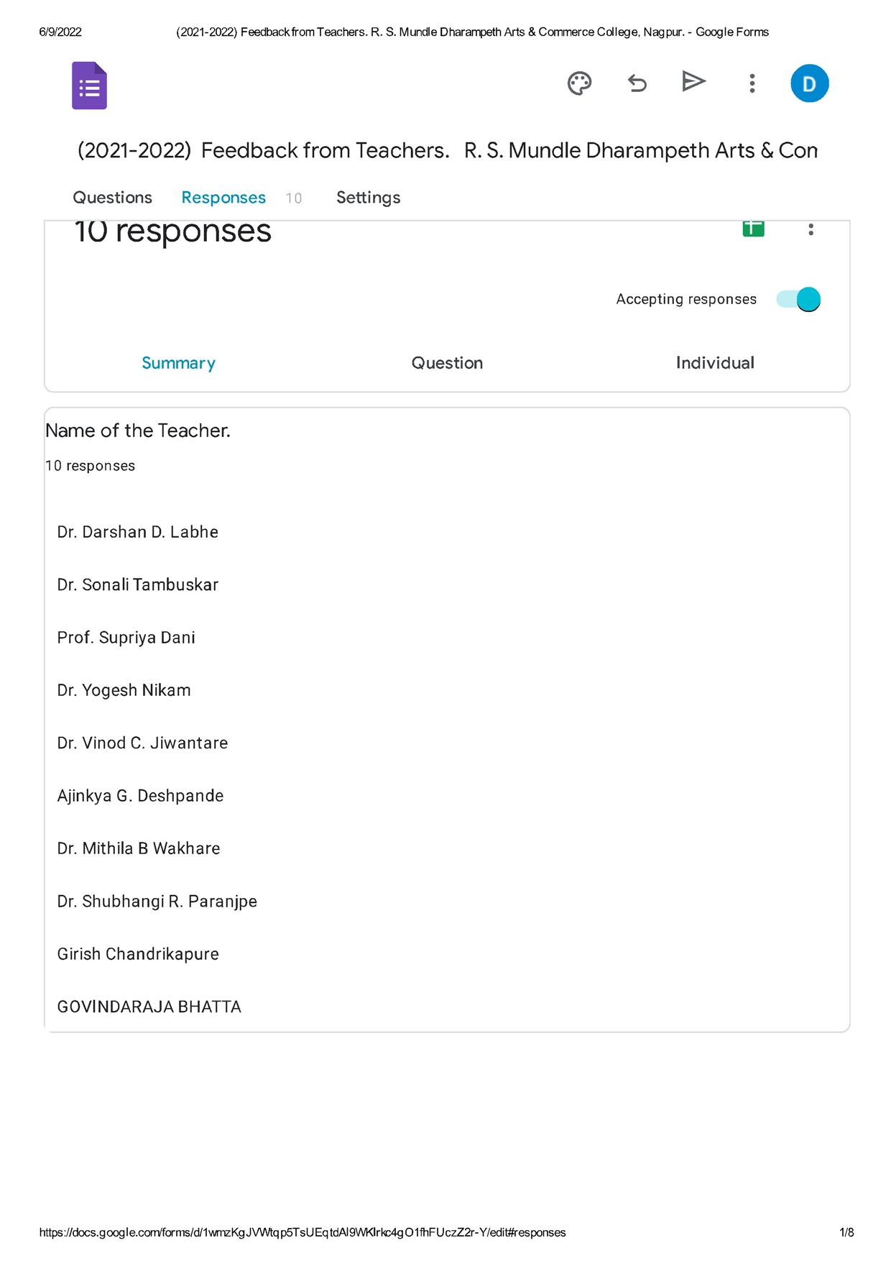

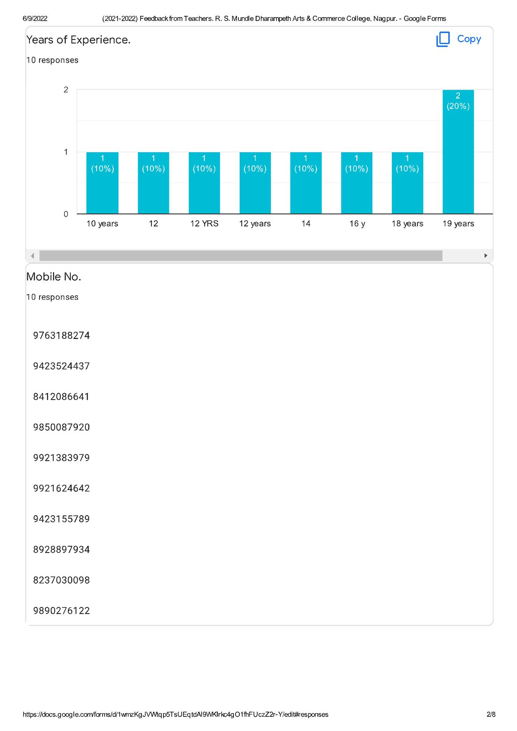
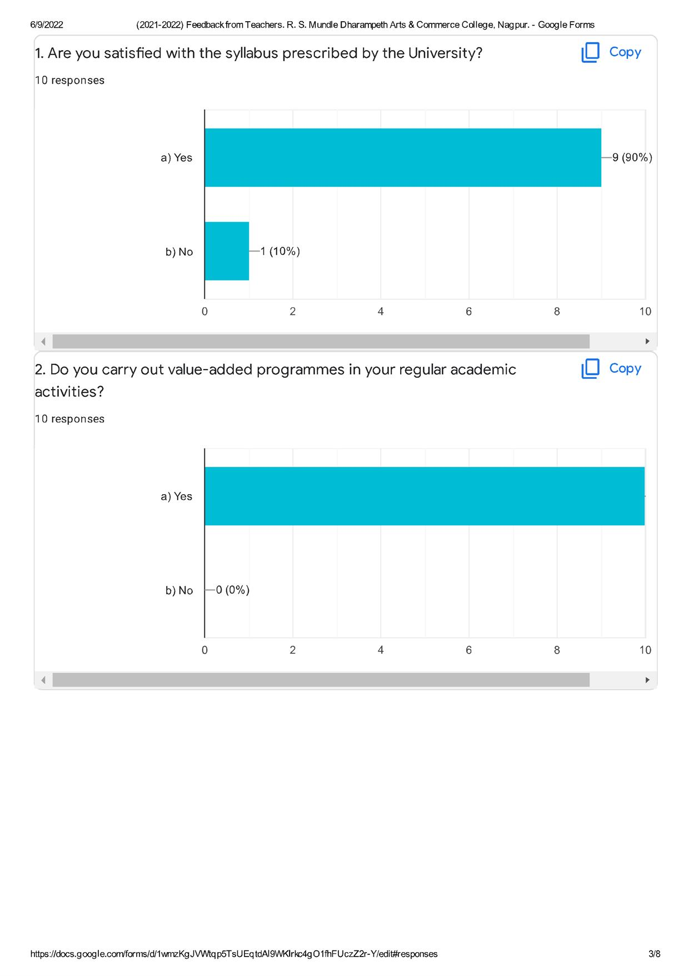

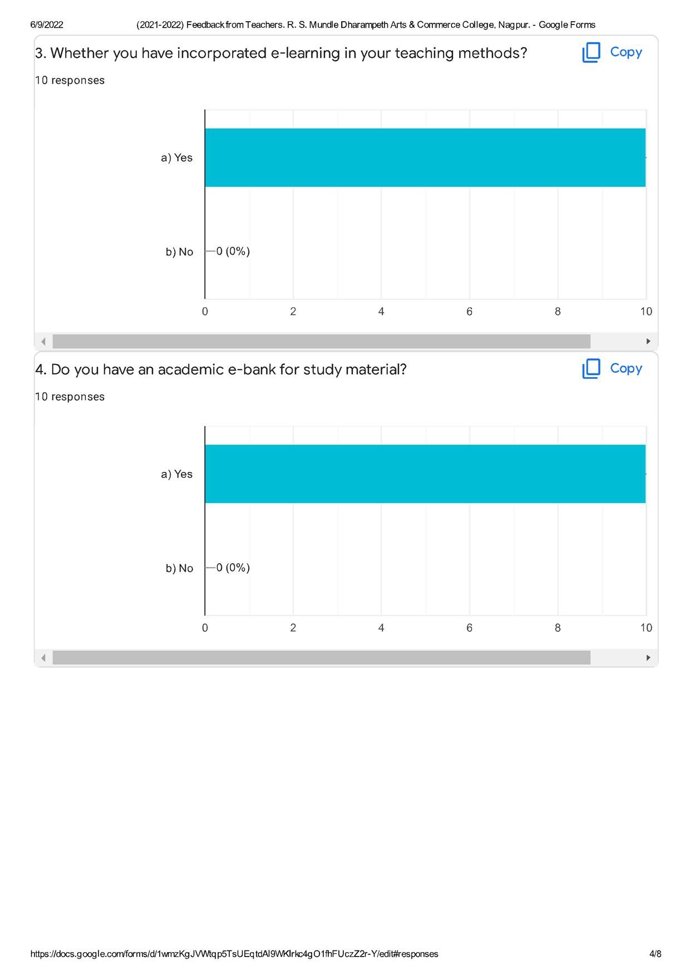

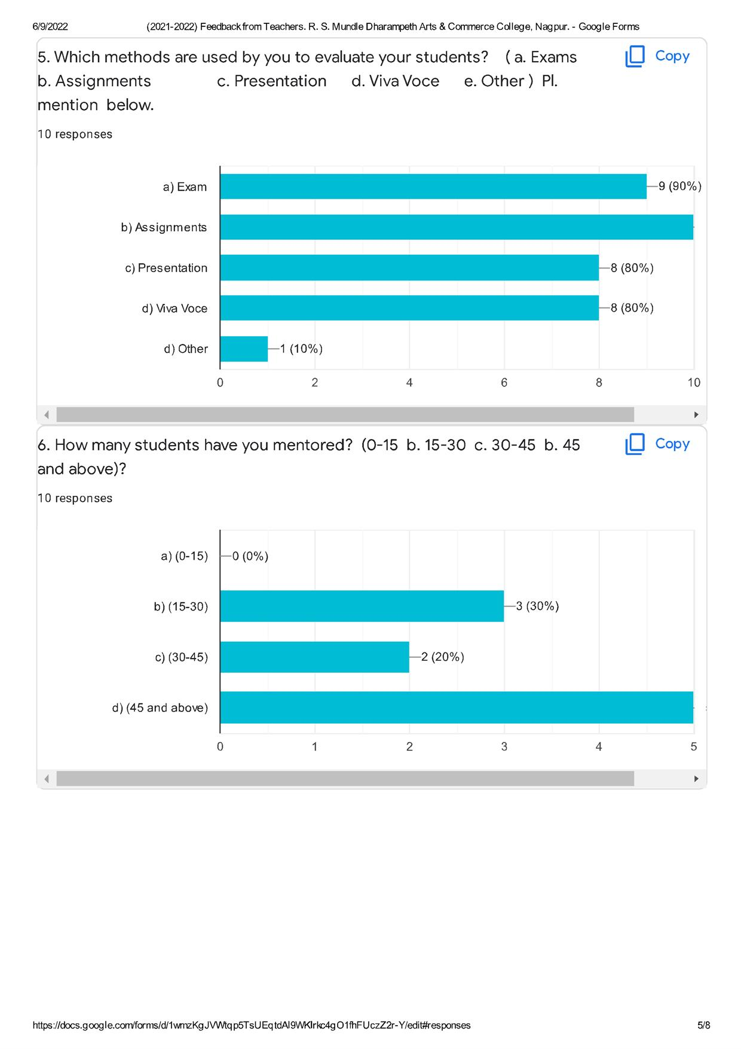

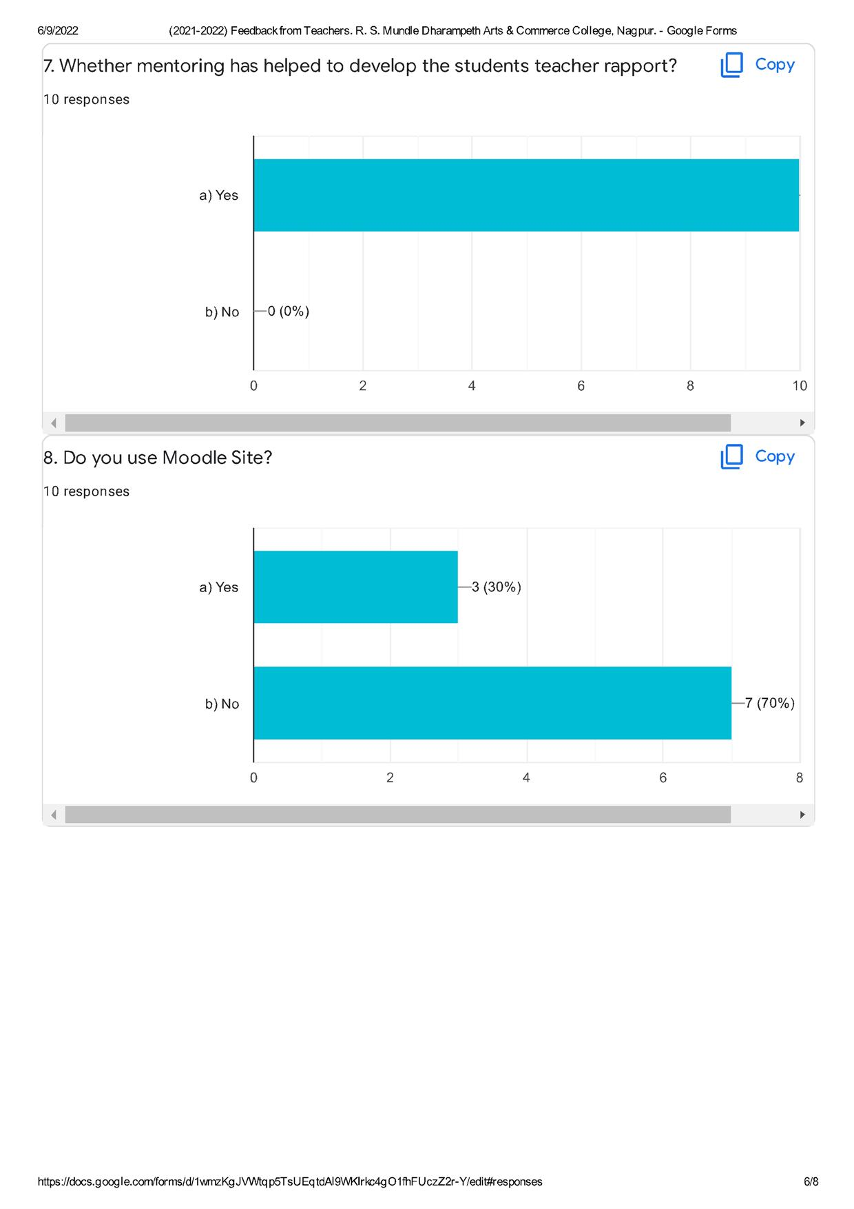

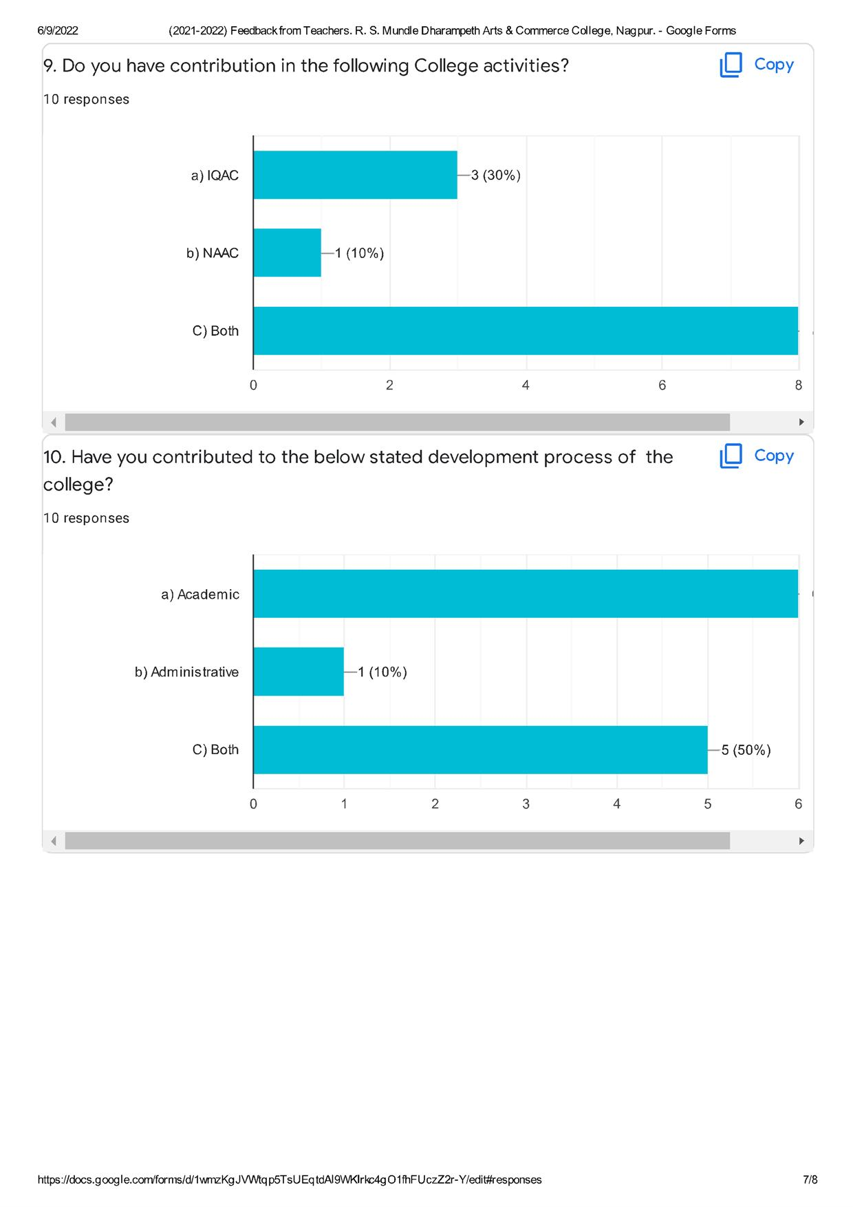

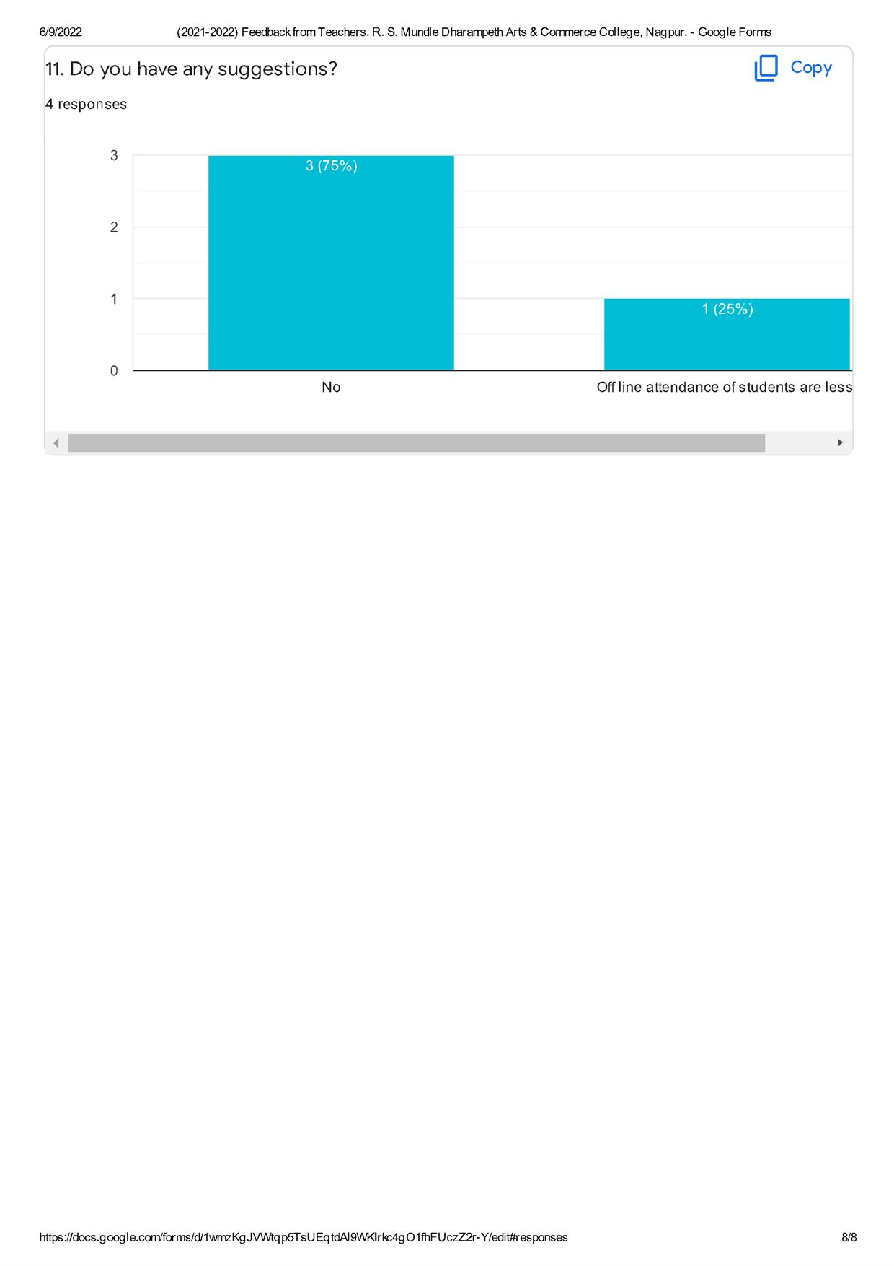

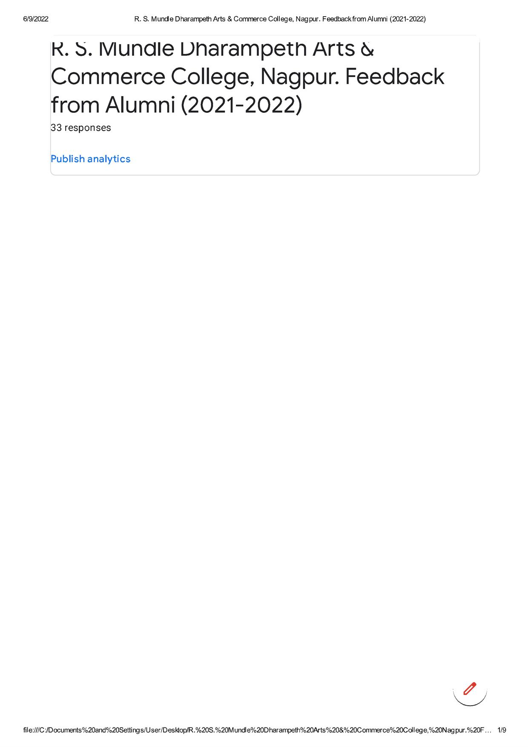

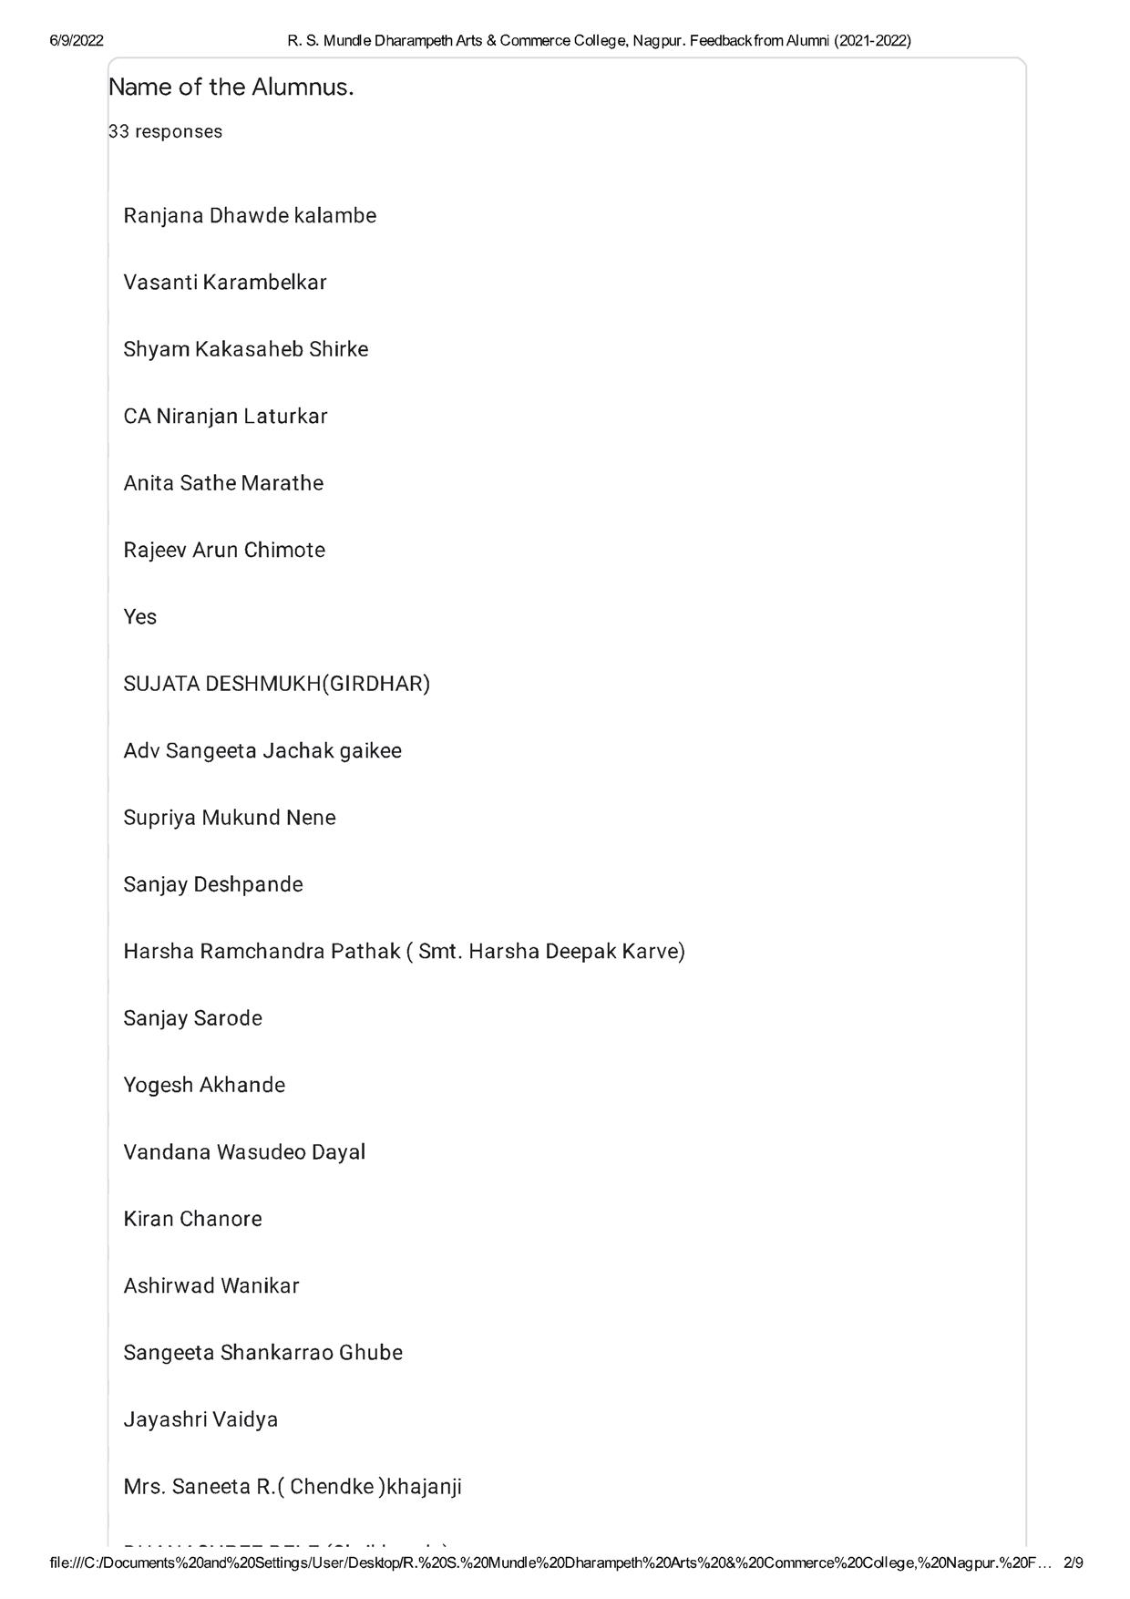

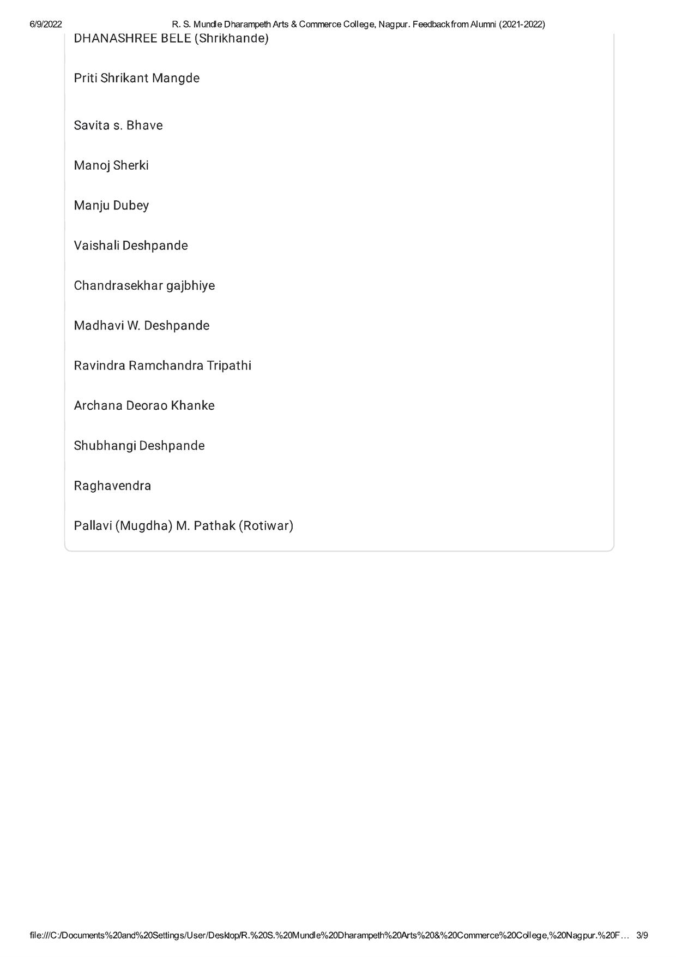
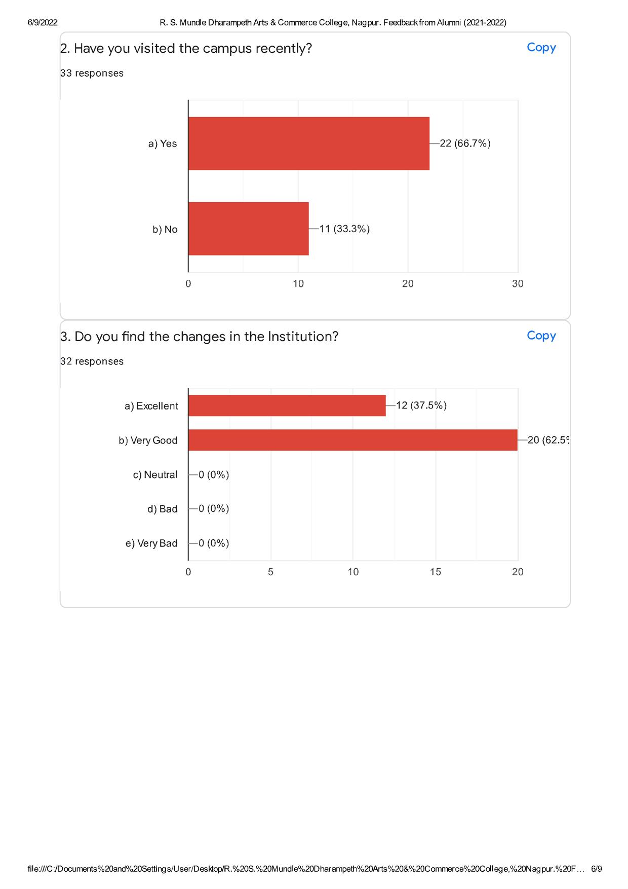

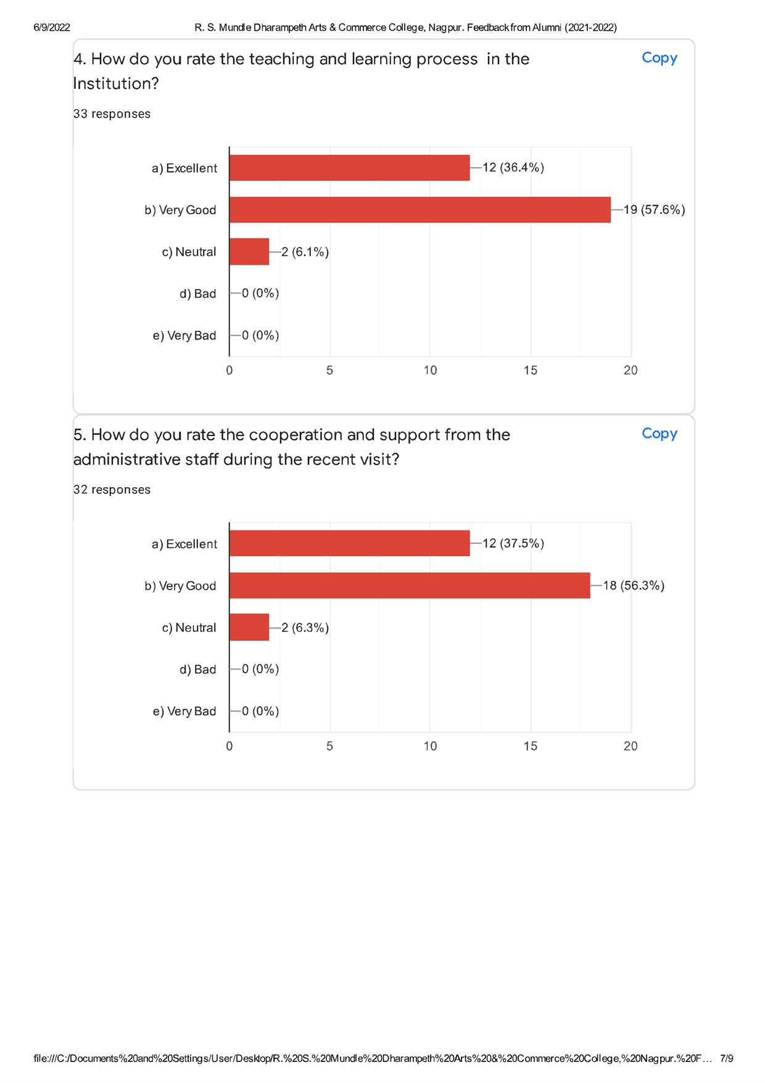

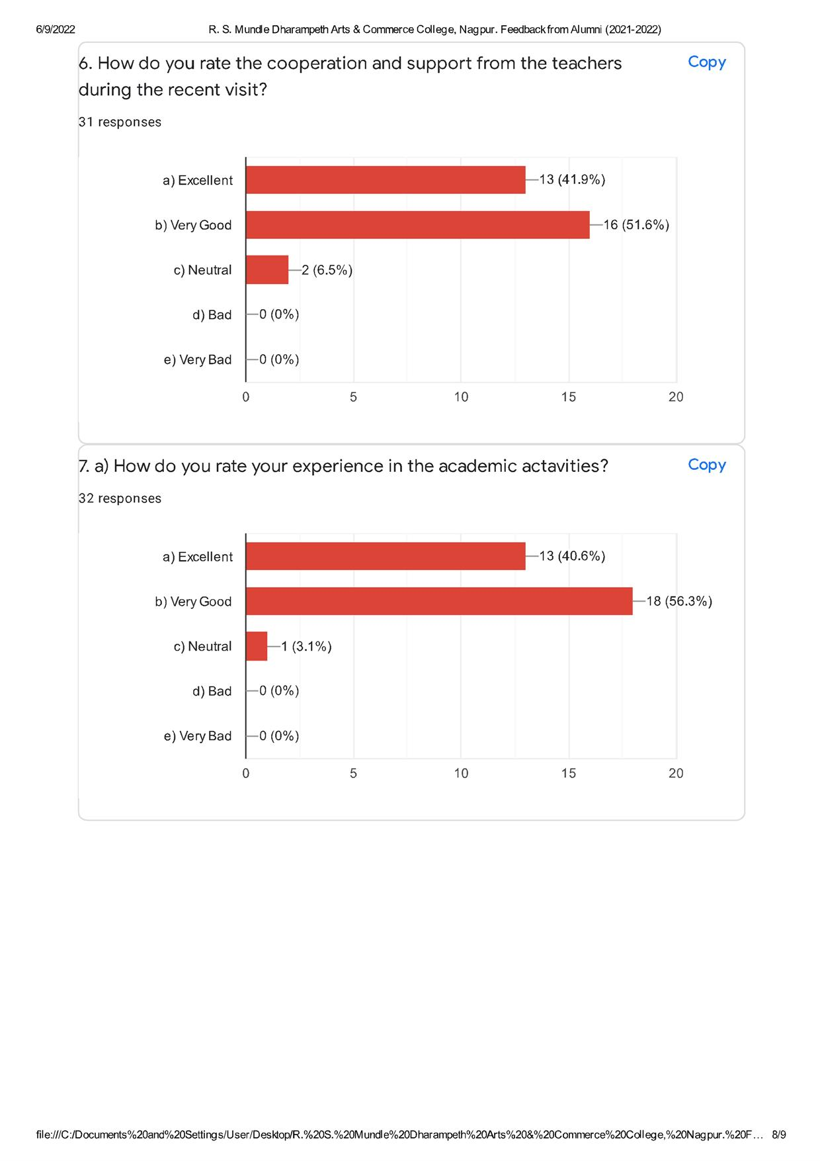

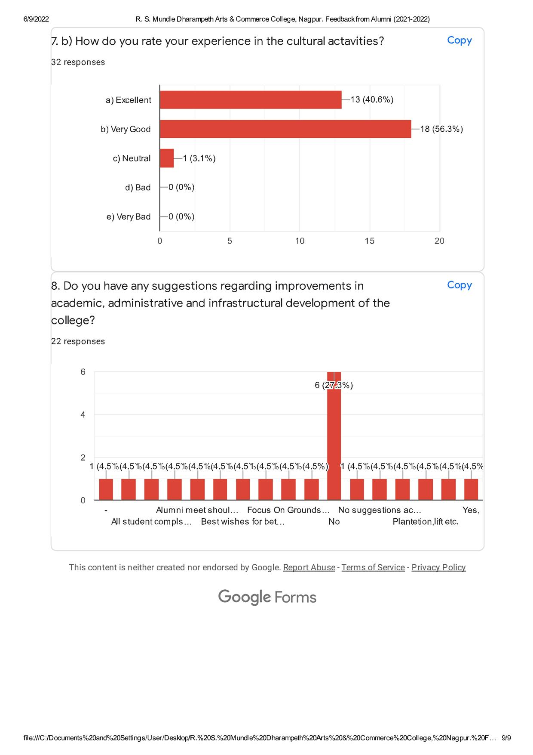

FEEDBACK FROM EMPLOYER FOR SESSION 2021- 2022.

- Percentage showing the employer view on duration for Internship. (40 Respondents)

Percentage showing the employer view on duration for Internship is Deficit | Percentage showing the employer view on duration for Internship is Appropriate | Percentage showing the employer view on duration for Internship is Enough
2.50 | 82.50 | 15.00

- Percentage showing the employer view on Student Performance. (40 Respondents)

Percentage showing the employer view on Students Performance is Average | Percentage showing the employer view on Students Performance is Satisfactory | Percentage showing the employer view on Students Performance is Good | Percentage showing the employer view on Students Performance is Best
0.00 | 42.00 | 45.00 | 12.50

- Percentage showing the employer Suggestion on student Performance. (40 Respondents)

Percentage showing the employer Suggestion on student Performance need to work hard | Percentage showing the employer Suggestion on student Performance Satisfactory | Percentage showing the employer Suggestion on student Performance was Excellent
0.00 | 65.00 | 35.00

- Percentage showing the employer Suggestion for the college on internship. (40 Respondents)

Percentage showing the employer Suggestion for the college on internship should be for Specific Stream | Percentage showing the employer Suggestion for the college on internship should not be for Specific Stream | Percentage showing the employer Suggestion for the college on internship should Possess Background
0.00 | 100.00 | 0.00

- Percentage showing the employer Suggestion. (40 Respondents)

Percentage showing the employer Suggestion | Percentage showing the employer with no Suggestion
12.50 | 87.50

